

**FACULTY OF INFORMATION AND COMMUNICATION TECHNOLOGIES**

**FALL 2023**

**FINAL EXAMINATION**

|  |  |
| --- | --- |
| **COURSE TITLE:** | CCNA1 |
| **COURSE CODE:** | ISN3201 |
| **INSTRUCTOR:** | Engr. Tanwi Nkiamboh |
| **DURATION:** | 1 week |
|  |  |
|  |  |
|  |  |
|  |  |

**INSTRUCTIONS:**

* **Attempt ALL the questions.**
* **Document your work. Write the corresponding codes against each question**
* **Include screenshots where necessary**

**PRACTICAL EXAM: Routing Fundamentals**

In this lab, you will configure and verify connected, local, static, summary and default routes. You will also examine the effect of longest prefix match routing.

All routers and switches are unconfigured at the start of the lab. The PCs have been configured with their network settings.

**Lab Topology**

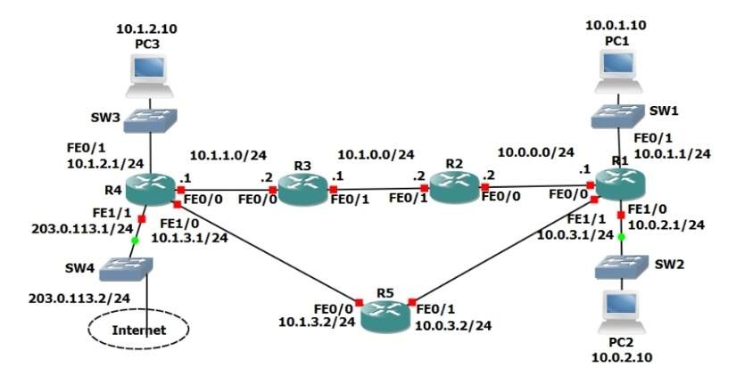

**Load the Startup Configurations**

Extract the project .pkt file then open it in Packet Tracer. Do not try to open the project directly inside the zip file.

**Activity 1: Connected and Local Routes (20 Marks)**

1) Say no when asked if you would like to enter the initial configuration dialog on each router.

2) Configure hostnames on the routers according to the Lab Topology diagram.

3) Configure IP addresses on R1 according to the Lab Topology diagram

4) Verify routes have been automatically added for the connected and local networks (note that local routes only appear from IOS 15)

5) Do you see routes for all networks that R1 is directly connected to? Why or why not?

6) Should you be able to ping from PC1 to PC2? Verify this.

(Click on PC1 then 'Desktop' and 'Command Prompt' to access its command line interface.)

7) Verify the traffic path from PC1 to PC2. Use the tracert' command.

8) Should you be able to ping from PC1 to PC3? Verify this.

**Activity 2: Static Routes (13 Marks)**

9) Configure IP addresses on R2, R3 and R4 according to the Lab Topology diagram. Do not configure the Internet Fast Ethernet 1/1 interface on R4. Do not configure R5.

10) Verify PC3 can ping its default gateway at 10.1.2.1

11)Configure static routes on R1, R2, R3 and R4 to allow connectivity between all their subnets. Use /24 prefixes for each network.

12)Verify connectivity between PC1, PC2 and PC3.

13) Verify the path traffic takes from PC1 to PC3.

**Activity 3: Summary Routes (12 Marks)**

14) Remove all the static routes on R1

15) Verify that PC1 loses connectivity to PC3

16) Restore connectivity to all subnets with a single command on R1.

17) Verify the routing table on R1 does not contain /24 routes to remote subnets.

18) Ensure that connectivity is restored between PC1 and PC3.

**Activity 4: Longest Prefix Match (15 Marks)**

19) Configure IP addresses on R5 according to the Lab Topology diagram

20) Do not add any additional routes. Does PC1 have reachability to the FastEthernet 0/0 interface on R5? If so, which path will the traffic take?

21) Ensure reachability over the shortest possible path from R5 to all directly connected networks on R1. Achieve this with a single command

22) Verify the path traffic takes from PC1 to the FastEthernet 0/0 interface on R5.

23) Verify the path the return traffic takes from R5 to PC1.

24) Ensure that traffic between PC1 and the FastEthernet 0/0 interface on R5 takes the most direct path in both directions.

25) Verify that traffic between PC1 and the FastEthernet 0/0 interface on R5 takes the most direct path in both directions.

**Activity 5: Default Route and Load Balancing (10 Marks)**

26) Configure an IP address on the Internet FastEthernet 1/1 interface on R4 according to the lab topology diagram.

27) Ensure that all PCs have a route out to the internet through the Internet Service Provider connection on R4. (Note that the lab does not actually have Internet connectivity.)

28) Traffic from PC1 and PC2 going to the internet should be load balanced over R2 and R5.

**ALL THE BEST**